**SUMMARY**

How do I process a MediSpan update on diskette or CD Rom or Download File?

**PROCEDURE**

Note: Some clients get only ONE CD. The CD should indicate NDC-GPI-PDED and Cross-Chek/Aller-Chek on it. If you only get one CD then when this documentation indicates that you should insert the next CD, you will leave the same CD in the drive.

Insert the CD labeled “NDC-GPI PDED” into the CD ROM drive.

* Download the file and unzip the file from the website to the desktop.
* Move the new files from the desktop into the “C” Drive directory and replace the following folders :
  + ACK
  + CC2
  + NDCGPI
  + PDE

Log Onto RxLink with a high-level security password.

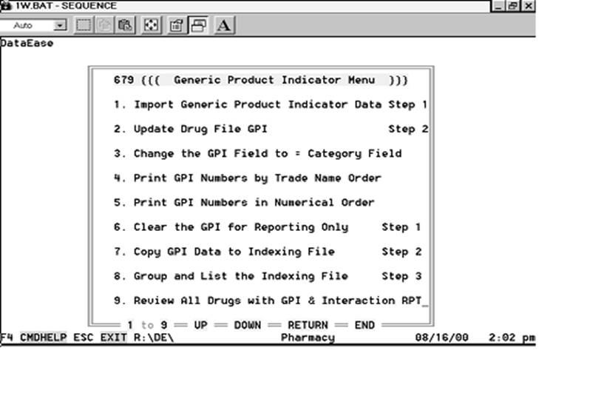

Update the NDC numbers first by going to menu choice 6791, Import Generic Product Indicator (GPI) Data.

You will see the following screen.    Simply press F2 to import from the CD.

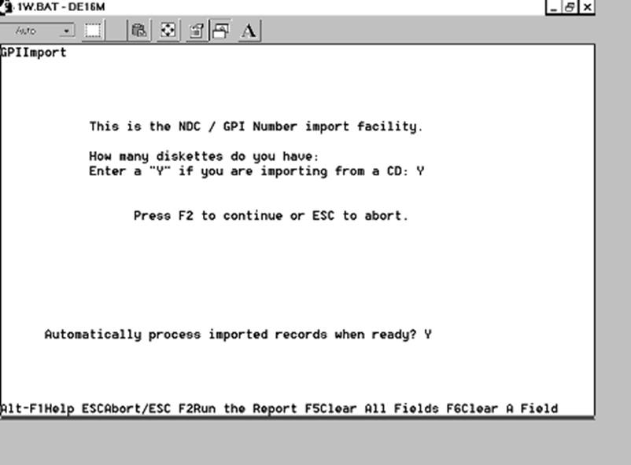After the CD light comes on, you will see it pulling records into RxLink, as in the following screen:

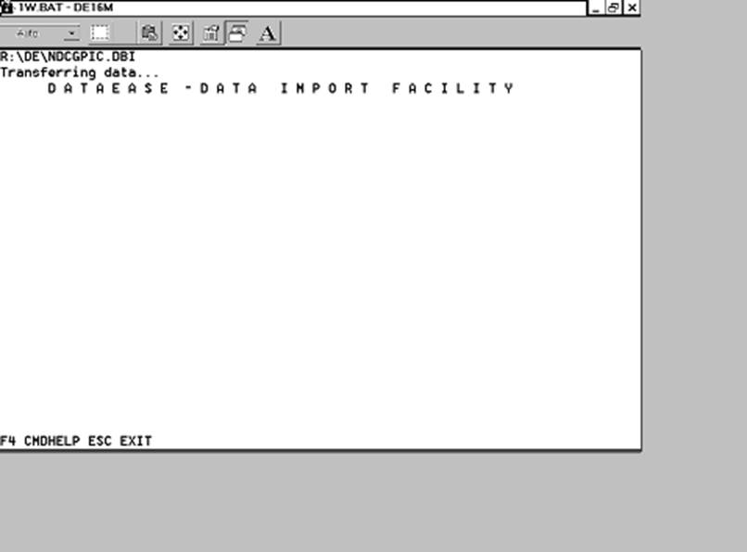

The number in red at the top may count as high as 100,000, or even higher.  Do NOT interrupt this process.

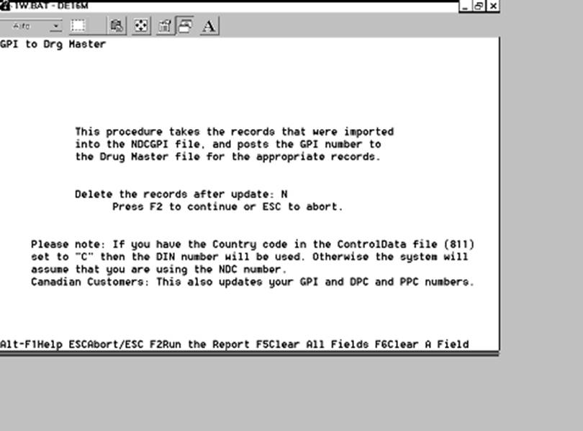

When it is done you will see another data-entry screen:

Just press the F2 key again to run this step….you will see progress messages in red at the top –

Again, do not interrupt this process…

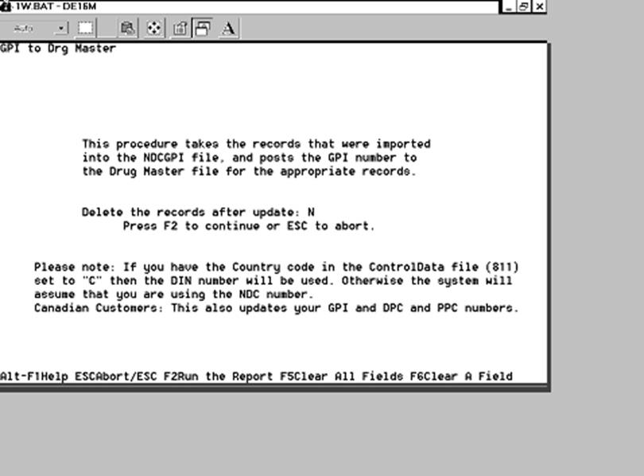

When it is done you will see the 679 menu.  Press ESC back to the Main (zero) menu.

To update the Patient Education data,  run menu choice 7829,  Update Patient Information From FDB: (Note – recent versions have removed the “2” menu.  If 7,8,9 on your system is “Update Patient Information on CD then choose 7,8,9 instead of 7,8,2,9).

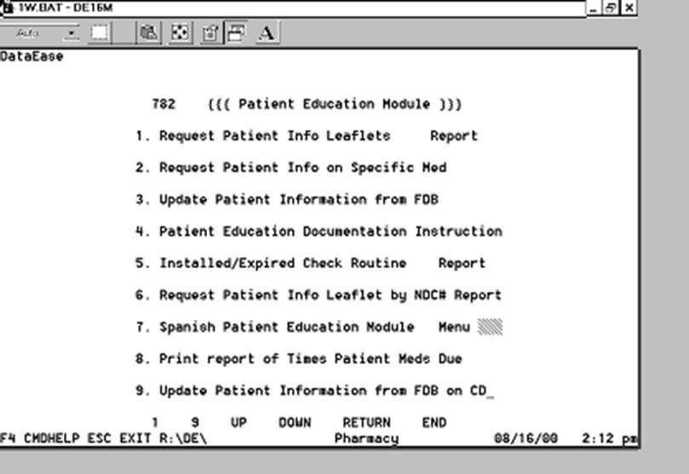

You will see the following screen:

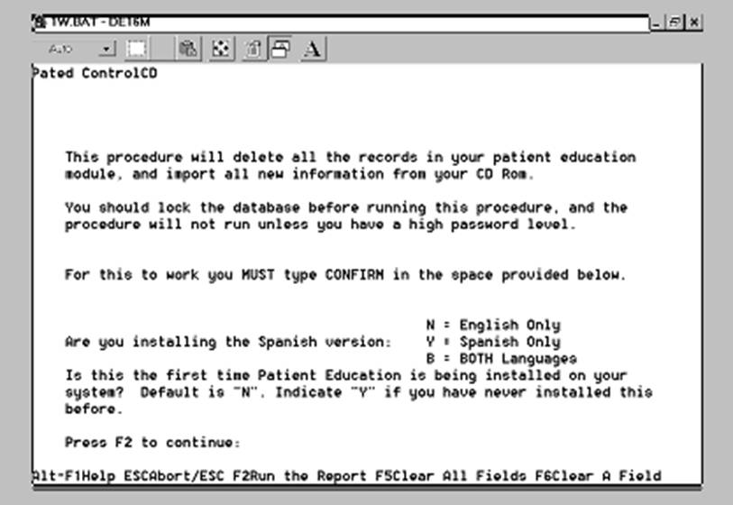

You will need to type the word “CONFIRM” if you are ready to run the report and answer the other questions to correctly update the data.  You  MUST  answer the following question correctly: **Is this the first time Patient Education is being installed on your system?  Default is "N". Indicate "Y" if you have never installed this before.**

Then press F2 to run the update – you will see a number of files copied from the CD Rom.

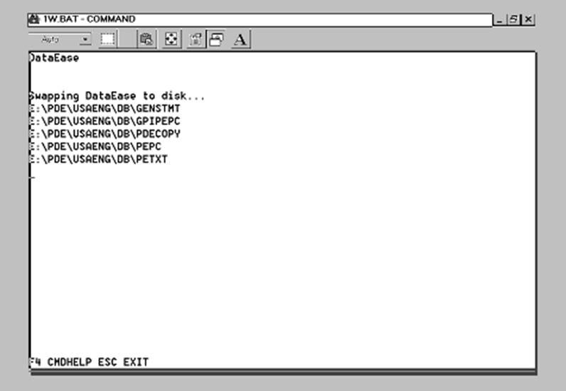

After this you will see a number of imports conducted, with numbers at the top counting up in red.  Do not interrupt this process. At the end of the process you will see the following screen message:

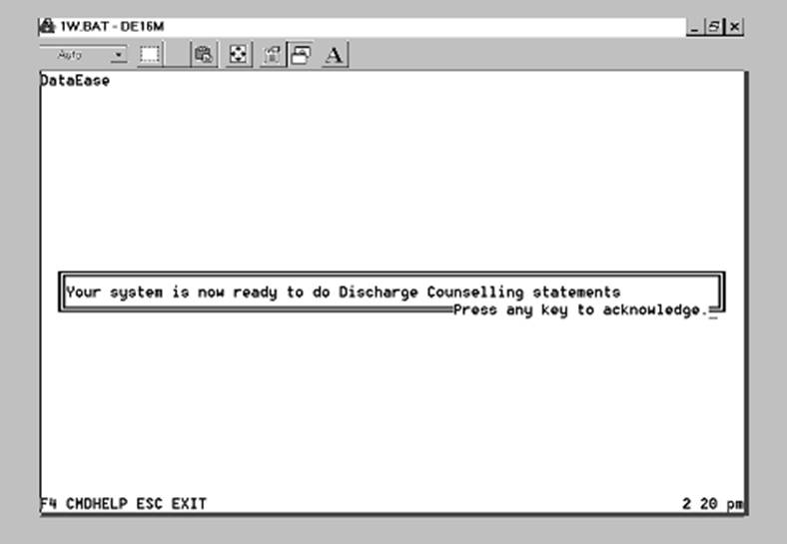

You are through with updating the patient education /discharge counselling data from FDB.

**Updating the Drug-Drug and Drug-Allergy Interaction data:**

Remove the CD from the drive and replace it with the CD labeled  “Cross-chek”.

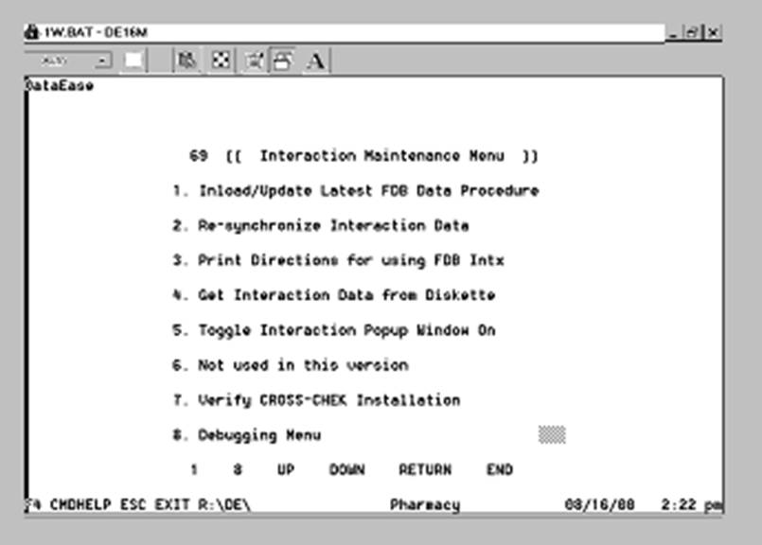

From the main (zero) menu, run  694 to import the data.

AllerCheck Files : “B”

Drive: “C”

Number diskettes for AllerCheck: “0”

You will need to indicate “B” in the first field, as in the example below, and then press F2 to run the import.

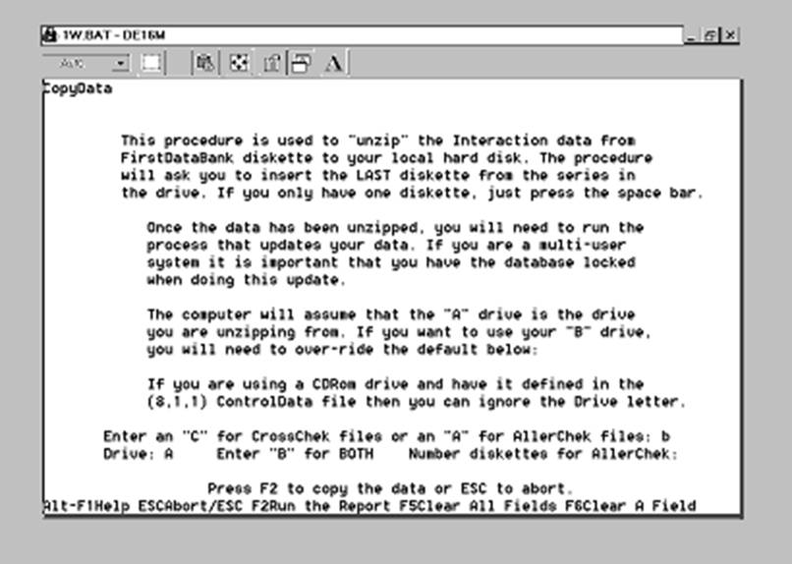

If you have a CD Rom drive installed then you can ignore the Drive letter. It will automatically use your CDRom drive letter.

You will see data copied from the CD, and then the 69 menu will be displayed.

You are now ready to run menu choice 691 to actually update the drug interaction data.

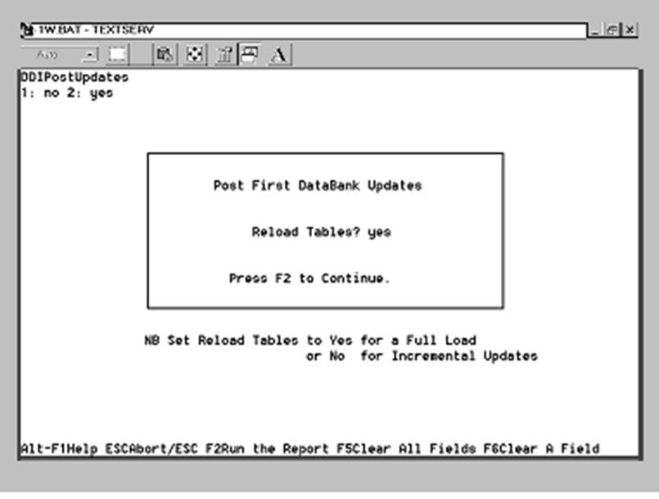

You will have to press “Y” for yes, and then F2, to start the process.   This can take as little as 15 minutes and as long as an hour, depending on the speed of your computer.  You cannot interrupt the process once it is begun!

You will see several imports (red numbers at the top of the screen counting upwards).  Do not interrupt the import process!    At the end, you will see a message on the screen reporting the total number of minutes required to perform the process.   Once you press any key to acknowledge then you are finished with the FDB quarterly updates.  Remove the CD from the drive.  Discard your LAST quarter’s CDs,  and store THIS QUARTER’s CDs  until your next set of CDs arrive and have been processed.

